Activity Report (2022 -2023)

Alumni Committee: Members:

Delhi College of Arts & Commerce (University of Delhi)

The Alumni Association of GDSC/DCAC organised its Annual Meet on 26 February 2023.

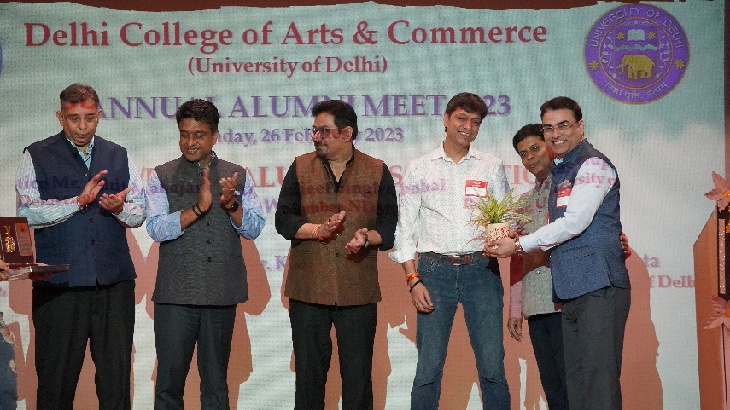

The event was inaugurated by our Guests of Honor: Honorable Justice Mr. Amit Mahajan, an esteemed judge in the High Court of Delhi; Mr. Kuljeet Singh Chahal, General Secretary BJP Delhi and Dr. Vikas Gupta, Registrar- University of Delhi. The meet commenced with the lighting of lamp by our esteemed guests, which was followed by a rendition of the *Saraswati vandana* by the members of the Music Society- Dastgah, DCAC. The event witnessed a great enthusiasm on the part of our distinguished alumni. The event was made possible beacuse of the presence of our alumni who came from all places far and near. In his wise and the humble welcome speech, our Principal, Prof. Rajiv Chopra focussed on the fact that it is a matter of pride for any institution to have its bright and talented students earing accolades for its alma mater. It is indeed a matter of pride for DCAC that a good number of its alumni are holding positions of responsibility in various sectors. Many of our alumni are now successful entrepreneurs who are job creaters. He praised their contribution towards the growth of their *alma mater* and emphasized the need for further strengthening the link between the Alumni and the current students.

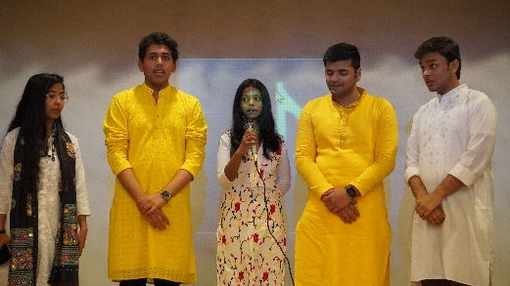 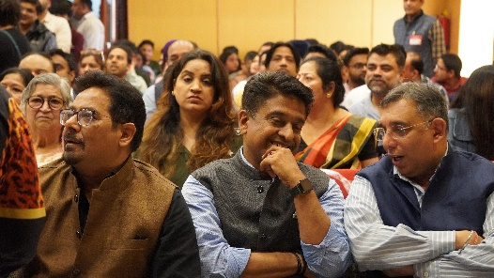

In the course of the ceremony, Prof. Rajiv Chopra’s speech was followed by a string of motivational speeches by our all Guests of Honor, who through their words of wisdom inspired the audience. The main attraction of the event was definitely a short video, prepared by the student volunteers of DCAC. The video gave a glimpse of the working of the various societies of the college. This was followed by the felicitation of our Distinguished alumni with mementos by our Principal, Prof. Rajiv Chopra, Convenor, Prof K. L. Dhingra, Honorable Justice Mr. Amit Mahajan, Mr. Kuljeet Singh Chahal and Dr. Vikas Gupta. The notable alumni, who were felicitated, were Mr. Rajinder Singh, Additional District and session judge; Mr. Rahul Raj Verma, Advocate and Legal Advisor; Mr. Suryaveer Hooja, well renowned singer; Mr. Gaurav Amlani, highly recognized actor; Mr. Gautam Kapoor, member NITI Aayog; Mr. Akhil Sachdeva, highly acclaimed singer and Col. BS Uppal (VSM), Infantary and Aviation Officer. The office bearers of the Alumni association under the guidance of their President, Mr. Amit Saxena were also felicitated by the esteemed panel for their tireless efforts in strengthening our Alumni.

The event was concluded with a sumptuous lunch served near the college canteen area. That was essentially a time for all to share personal anecdotes about their time in university and also taught the current students how to get by troubling times. Many of the current students were also seen interacting with their seniors and learning from their experiences. The scane of all chatting and dancing in groups was beautifully captured by our photography team. A jamming session with renditions of classic songs was also held which was thoroughly enjoyed by all.

The event witnessed the active involvement of the alumni, and a number of commendable suggestions and proposals came up. It was decided to strengthen the link between the current DCAC students and the alumni for the support of the alumni in the areas of training, placement and career counseling which would really benefit the current students. The Alumni Meet came to a memorable end with everyone bidding farewell with the promises to meet again.

